BREVO – TELECRM Integration
Scope:
- Lead Synchronization between Brevo and TeleCRM only in the following field:
- When contact unsubscribe in Brevo the lead status in TeleCRM charge to “Lost” automatically. (Essential)
- When the mail come back as “mail daemon” in Brevo the lead status in TeleCRM need to flag as error in the mail field – advise about it in which way we can flag in TeleCRM maybe with an automation in TeleCRM which mark in the field of the leads as “mail not correct”, so when I use the filter I am able to identify which leads have the mail not correct and exclude them from the next mail campaign that I create in TeleCRM. (Essential)
- I would like to capture the answer received via mail into the “Note” field for each leads in TeleCRM, if it possible, otherwise it is not a problem. (Not essential, but a good to have feature)
- Campaign will be created in TeleCRM divided per label which it is essentially the category of the leads and these leads are pulled to Brevo with all the relative fields (if it is required for the scope) (Essential)
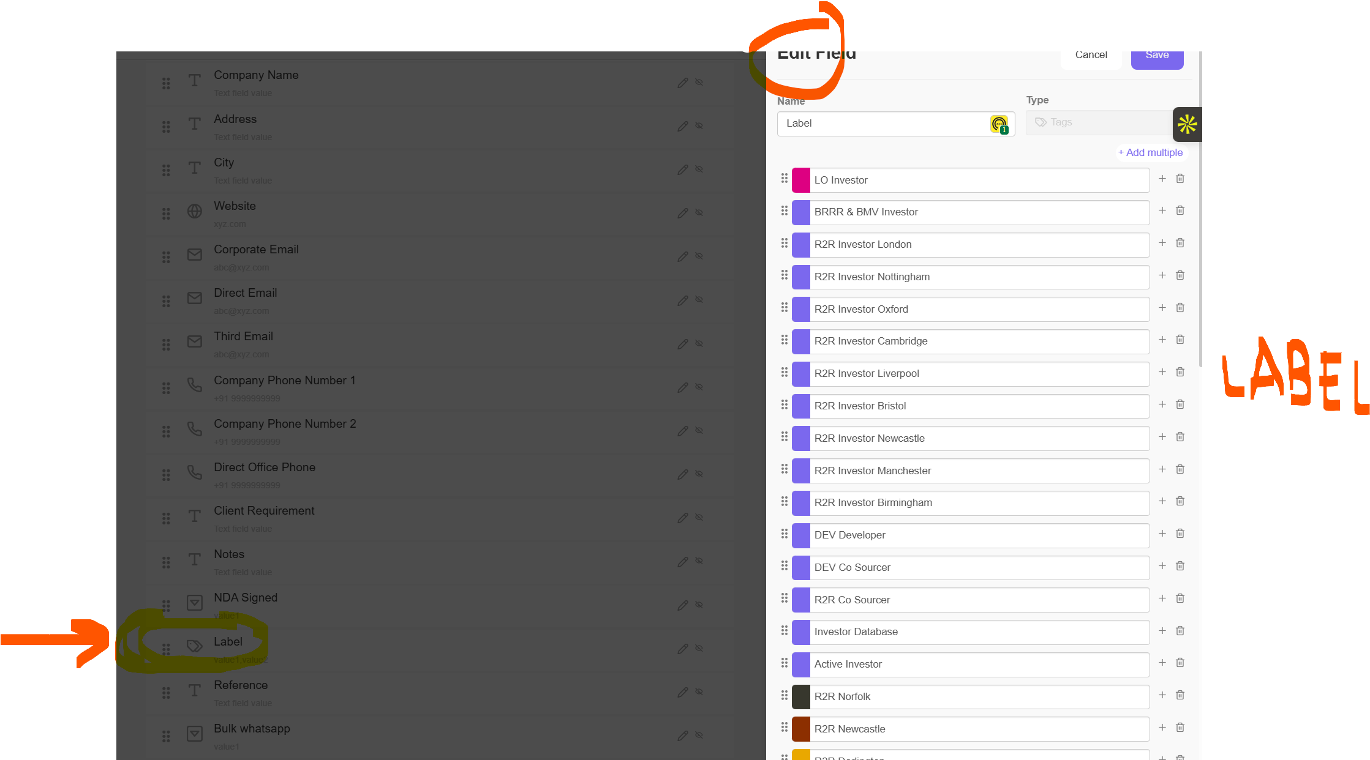
- I need to need to have a “return receipt” of the mail sent from the client. I believe I can setup this in Brevo. – advise about it (Essential)
- I need to have some sort of simply statistic of open rate, mail not read etc. I believe I can setup this in Brevo. – advise about it (Essential)
- Templated in Brevo need to be a very simply blank mail (I don’t want that it looks like a newsletter) with the link to my privacy policy and unsubscribe link on the bottom – I believe I can setup this in Brevo. – advise about it (Essential)
- I want to setup automatic follow up to the mail sent with Brevo with 1st, 2nd and 3rd follow up based on pre-defined templates – especially when engaging with new leads campaign. (Not essential, but a good to have feature)
- I will use the Template to create different e-mail for each campaign (Essential)
- I will create other Template in the future and I need to be able to sync with TeleCRM. (Essential)
- This system needs to work for every Workplace I have in TeleCRM (Not Essential for now)
- The mail needs to be sent from info@abgrouponline.com which is my corporate e-mail, but in the future also form other e-mail. (Essential)

From TeleCRM:
Since, we are proceeding with the brevo integration. Following are the points that we will cover.
1. Use Brevo API and integrate it with telecrm.
2. Create an automation that whenever you'll update a field/stage manually, only then the mail will be triggered.
Also,
1. We will not be creating any template for you.
2. We are not responsible for backenforth of data from telecrm to brevo.
3. We'll not be making any changes in your brevo profile.
While integration,
We will fetch the details like API Key and endpoint URL from the brevo API documentation, rest for the template part, once your template in brevo is ready we'll be needing template ID only.

From Brevo:
Thanks for reaching out about this!
To go into detail on each point please see below:
1- Yes this is possible with Brevo API. You can access our developer documentation here: https://developers.brevo.com/
2- This would need to be set up through a third party, such as Zapier but is possible. Brevo automatically records unsubscribed but to push it over would need a third party.
3- This can be done via segmentation, more information is available here:nhttps://help.brevo.com/hc/en-us/articles/11482358925458-Segment-your-contacts-using-a-segment-template
4 &5 - This can also be achieved through automations. (https://help.brevo.com/hc/en-us/articles/208775609-Introduction-to-Marketing-Automation)
6- Yes, more information can be found with webhooks: (https://help.brevo.com/hc/en-us/articles/360007666479-Create-webhooks-to-receive-real-time-updates-about-your-emails-and-contacts)
7 - While we do have a spam checker, it is not to be used as a cleaning service and is instead used to help prevent fraudulent and spam emails on the platform. We suggest ensuring that your database is clean before sending a campaign.
8 - While this is possible, you would need to self-manage this. It will go through one SMTP port, but you can make several keys for multiple.
9- Finally, yes, all of this can be done in the Brevo editor!
I would also like to clarify that Brevo is a self-service platform. So while we are always happy to help with questions, all of this will need to be set up on the user side.
I hope this helps!

